Team ID: SWTID-2026-3898
BANQUET HALL BOOKING CRM APPLICATION

User Story:
As a banquet hall manager, I want to efficiently manage customer bookings and streamline the entire event reservation process using the Banquet Hall Booking CRM application. I want to easily check hall availability, create and update booking records, and maintain detailed customer information so that I can avoid scheduling conflicts and provide better service.
Additionally, I need the system to allow clients to specify their event requirements such as date, number of guests, seating arrangements, catering preferences, and special requests, ensuring that all event details are properly recorded and managed.
Moreover, I want the application to automate booking confirmations, payment tracking, and notifications so that both customers and staff are always informed about booking status and upcoming events. I also require the ability to generate reports and dashboards to analyze booking trends, revenue, and hall utilization, which will help in making better business decisions and improving operational efficiency.
Lastly, I would like the system to support seamless coordination between event planners and staff, ensuring that all arrangements such as décor, catering, and audiovisual setup are executed smoothly on the event day, thereby enhancing customer satisfaction and overall service quality.

1. INTRODUCTION
1.1 Project Overview
The project “Banquet Hall Booking CRM Application” focuses on developing a system to manage and streamline the process of booking banquet halls for various events such as weddings, corporate meetings, birthday parties, and social gatherings.
The system allows clients to check availability, submit booking requests, and customize event requirements. It also enables banquet hall administrators to manage bookings, customer details, event planning, and payments efficiently.
The application automates the entire booking lifecycle from inquiry to event execution ensuring smooth coordination between clients and the management team.

1.2 Purpose
The purpose of this project is to:
- Simplify banquet hall booking process
- Automate event scheduling and management
- Reduce manual errors and double bookings
- Improve customer experience
- Enable efficient communication between clients and staff
- Provide real-time booking and availability tracking

2. IDEATION PHASE
2.1 Problem Statement
P S | Customer | I’m trying to | But | Because | Which makes me feel
PS-1 | Customer | Book a banquet hall | Availability is unclear | No centralized system | Frustrated
PS-2 | Manager | Manage multiple bookings | Records are manual | No automation | Overwhelmed
PS-3 | Event Planner | Coordinate events | Miscommunication occurs | No tracking system | Stressed

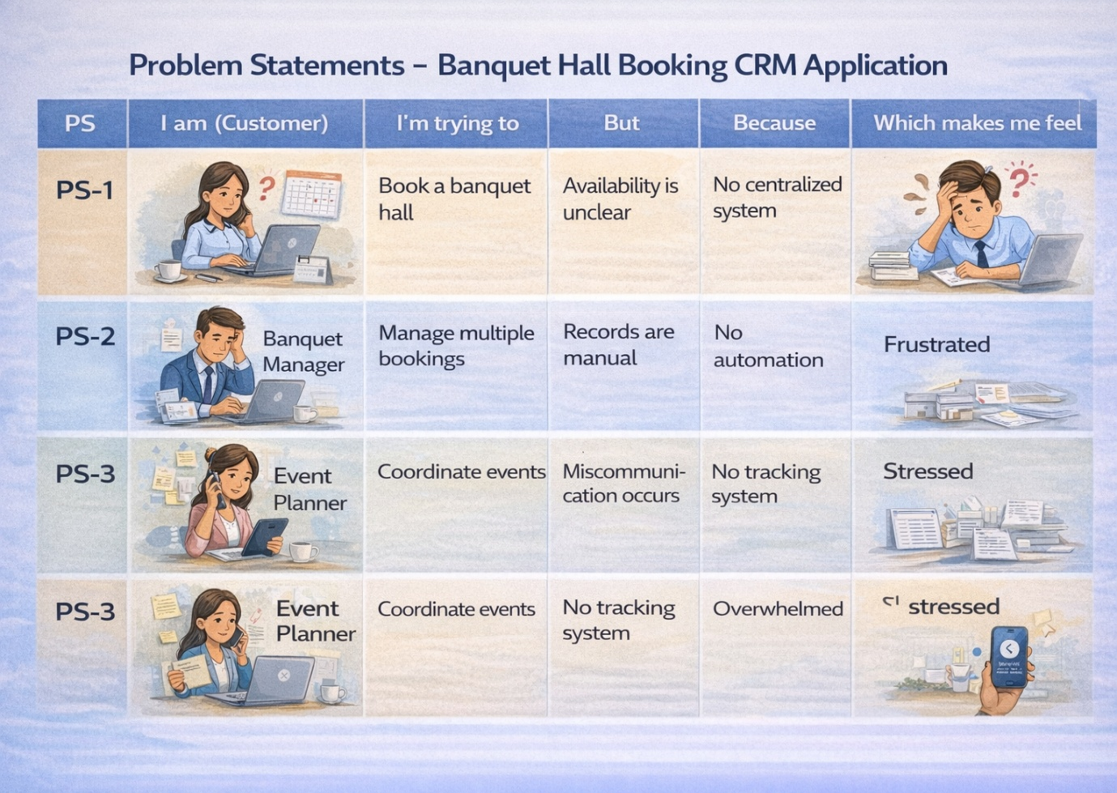

2.2 Empathy Map Canvas
Target Users:
- Customers
- Banquet Managers
- Event Coordinators
- Admins
Empathy Analysis:
Aspect | Description
Think & Feel | Want easy booking and smooth event planning
Hear | Suggestions from friends, staff updates
See | Multiple booking records and confusion
Say & Do | Contact manually, follow up repeatedly
Pain | Double booking, delays, miscommunication
Gain | Automation, accuracy, convenience

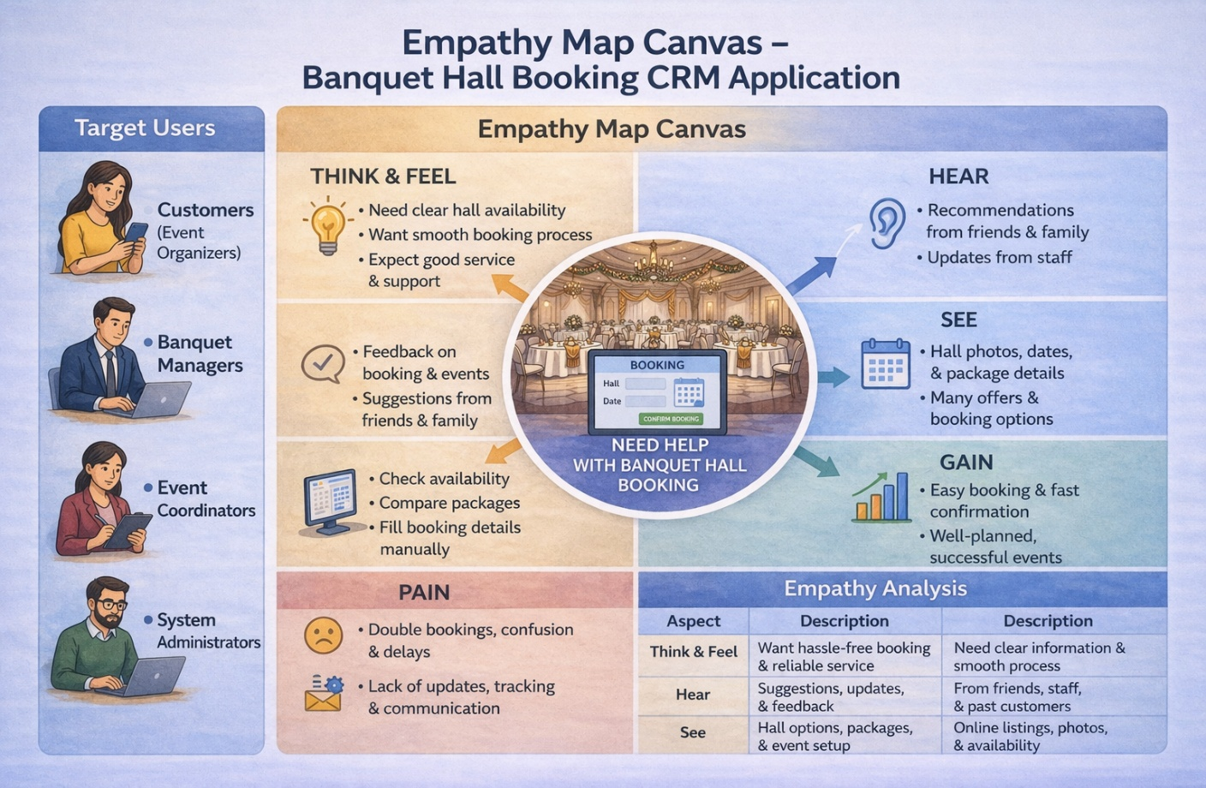

2.3 Brainstorming
Ideas Generated:
- Manual booking system
- Excel-based tracking
- Web-based booking portal
- Mobile application
- CRM-based booking system
Selected Idea:
CRM-based Banquet Hall Booking Application

3. REQUIREMENT ANALYSIS
3.1 Customer Journey Map
Stages:
- Inquiry for booking
- Check availability
- Submit booking request
- Confirm booking
- Customize event details
- Payment processing
- Event execution
- Feedback

3.2 Solution Requirements
Functional Requirements

FR No | Requirement
FR-1 | User Login
FR-2 | Hall Availability Check
FR-3 | Booking Management
FR-4 | Event Customization
FR-5 | Payment Processing
FR-6 | Notification System

Non-Functional Requirements
NFR-1: Usability
The system should be easy to use for customers, banquet managers, event coordinators, and administrators without requiring technical knowledge.
Requirements:
- Simple and intuitive user interface
- Easy navigation between booking and management modules
- Clear and user-friendly booking forms
- Interactive and understandable dashboards
Example:
A new user should be able to check hall availability, fill booking details, and confirm a reservation within a few minutes without assistance. The system interface should guide users step-by-step for a smooth experience.
NFR-2: Security
The system must protect customer data, booking details, and payment information from unauthorized access.
Requirements:
- Secure login authentication
- Role-based access control
- Encrypted data storage
- Secure payment handling
- Data backup and recovery
Examples:
- Admins can access all booking data, while customers can only view their own bookings
- Secure password policies and login verification
- Restricted access to financial and booking records
NFR-3: Reliability
The system should function correctly at all times and ensure accurate storage of booking and event data without loss.
Requirements:
- Automatic data saving
- Regular system backups
- Error handling mechanisms
- Stable system performance
Example:
If a customer is booking a hall and the internet connection is interrupted, the system should save the entered details and allow the user to continue without losing data.
NFR-4: Performance
The system should respond quickly and efficiently handle multiple bookings and users simultaneously.
Requirements:
- Fast page loading
- Quick booking confirmation
- Efficient database queries
- Minimal response time
Example:
When multiple users check hall availability at the same time, the system should display results instantly without delays.
NFR-5: Availability
The system should be accessible at all times for booking and management purposes.
Requirements:
- 24/7 system availability
- Minimal downtime
- Cloud-based deployment
- Disaster recovery mechanisms
Example:
Customers should be able to book halls anytime (day/night), and managers should access booking data even during peak event seasons.
NFR-6: Scalability
The system should support increasing users, bookings, and expansion of banquet halls without affecting performance.
Requirements:
- Ability to handle multiple users simultaneously
- Support increasing booking data
- Expandable storage capacity
- Maintain system speed under load
Example:
If the business expands to multiple banquet halls or locations, the system should manage thousands of bookings efficiently without slowing down.

3.3 Data Flow Diagram
Client → Application UI → Booking Module → Database → Event Management → Reports
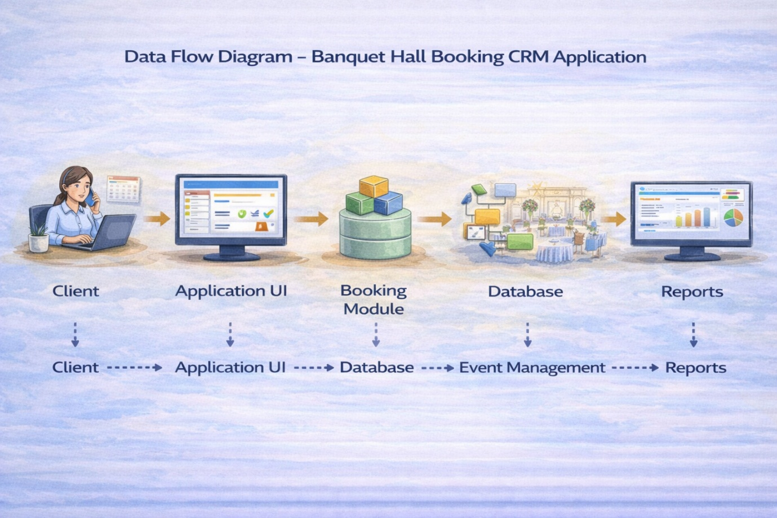

3.4 Technology Stack
Layer | Technology
Frontend | HTML, CSS, JavaScript
Backend | Java / Node.js
Database | MySQL
Platform | Web / Salesforce (optional)
Analytics | Reports & Dashboards

4. PROJECT DESIGN
4.1 Problem–Solution Fit
Manual booking systems lead to confusion, errors, and inefficiency.
The proposed CRM system automates booking, scheduling, and communication, ensuring accuracy and better customer experience.

4.2 Proposed Solution
Feature | Description
User Authentication | Secure login system
Booking System | Manage reservations
Event Management | Customize event details
Availability Check | Prevent double booking
Payment Module | Manage transactions
Notification System | Email/SMS updates
Reports | Booking analytics

4.3 Solution Architecture
Layers:
- Presentation Layer – User Interface
- Application Layer – Business Logic
- Data Layer – Database
- Analytics Layer – Reports

5. PROJECT PLANNING & SCHEDULING
5.1 Project Planning
- Agile development approach
- Requirement gathering
- System design
- Development and testing
- Deployment
Sprint Plan (Example):
Sprint | Task
Sprint 1 | Setup & Database
Sprint 2 | Booking Module
Sprint 3 | Event Management
Sprint 4 | Payment & Notifications
Sprint 5 | Reports & Dashboard

6. FUNCTIONAL AND PERFORMANCE TESTING
6.1 Performance Testing
- Tested booking system for multiple users
- Verified response time
- Ensured no duplicate bookings
- Checked system stability

7. RESULTS
7.1 Output Screenshots
- Login Page
- Booking Form
- Availability Dashboard
- Event Management Screen
- Reports Dashboard

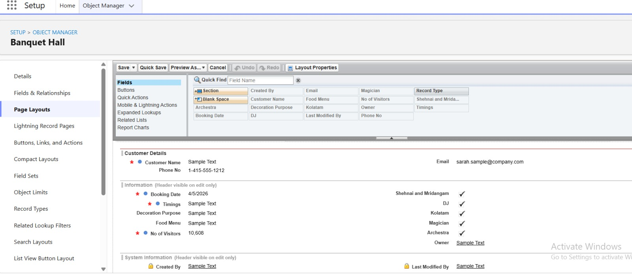

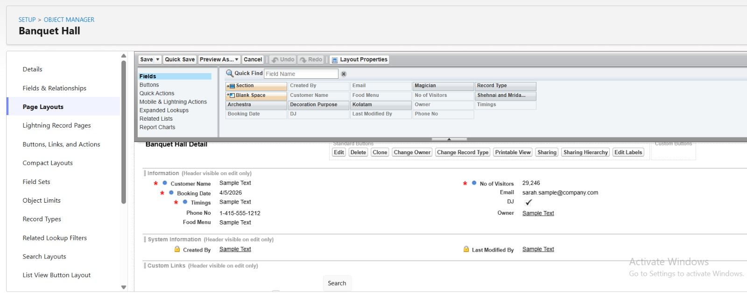

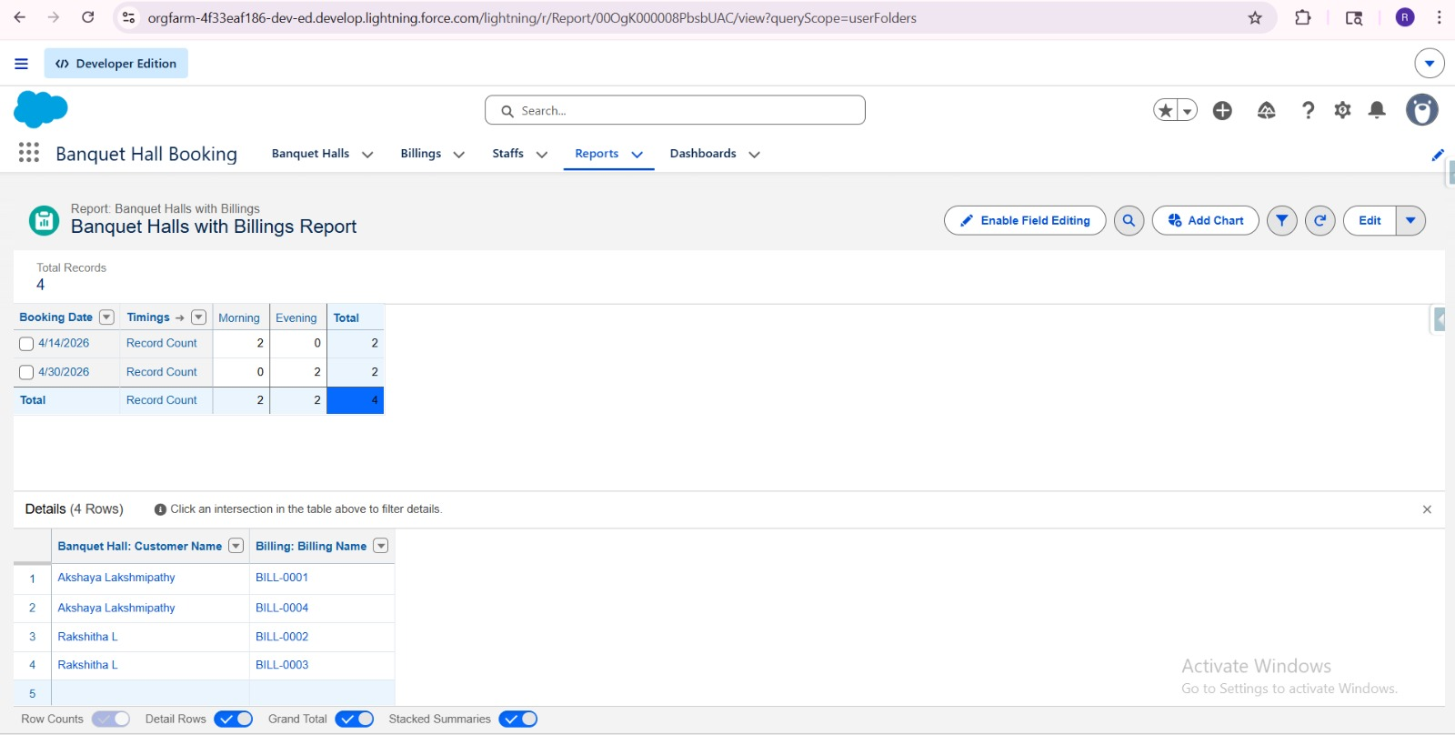

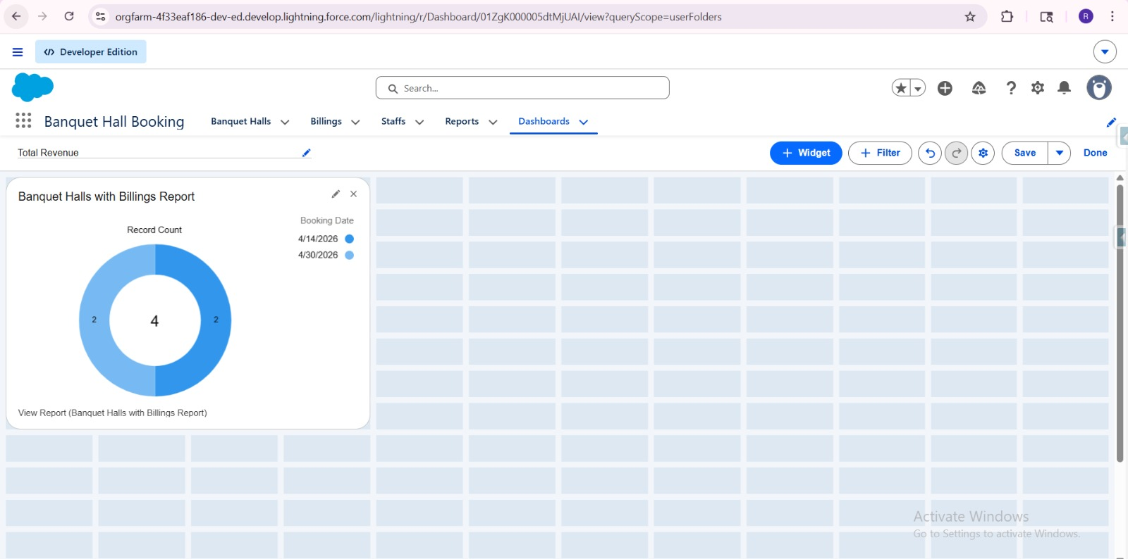

8. ADVANTAGES & DISADVANTAGES
Advantages
- Easy booking process
- Reduces manual errors
- Real-time availability
- Improved customer satisfaction
- Better management

Disadvantages
- Requires internet connection
- Initial setup cost
- Training required

9. CONCLUSION
The Banquet Hall Booking CRM Application successfully streamlines the booking and event management process. It reduces manual effort, improves efficiency, and enhances customer experience through automation and real-time tracking.

10. FUTURE SCOPE
- Mobile application
- AI-based event recommendations
- Online payment integration
- Chatbot support
- Multi-branch hall management

11. APPENDIX
Source Code:
Salesforce Configuration & Flows
GitHub & Demo Link:
GitHub:
https://github.com/karunya-j/A-CRM-Application-For-Banquet-Hall-Booking
Demo: https://drive.google.com/drive/folders/1mG2bQgxBCxaUYxDqm8H5fAOu_J05Ebcd?usp=drive_link

